Chapter 4, Solution 91.

- In the Wheatstone bridge circuit of Fig. 4.147 select the values of R₁ and R₃ such that the bridge can measure R_{x} in the range of 0-10 Ω.
- Repeat for the range of 0-100 Ω.

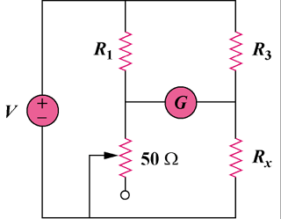

Figure 4.147
For Prob. 4.91.

Solution

R_{x} = (R₃/R₁)R₂

(a) Since 0 < R₂ < 50 ohms, to make 0 < R_{x} < 10 ohms requires that when R₂ = 50 ohms, R_{x} = 10 ohms.

10 = (R₃/R₁)50 or R₃ = R₁/5

so we select R₁ = 100 ohms and R₃ = 20 ohms

(b) For 0 < R_{x} < 100 ohms

100 = (R₃/R₁)50, or R₃ = 2R₁

So we can select R₁ = 100 ohms and R₃ = 200 ohms

